COA – LS1

# Add 2 Numbers

CODE:

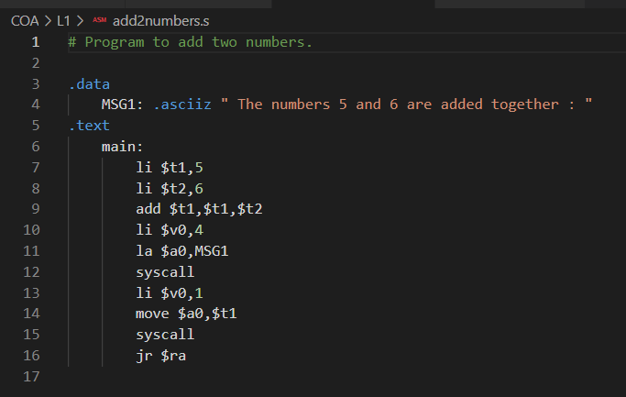

OUTPUT:

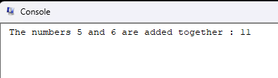

# Sub 2 Numbers

CODE:

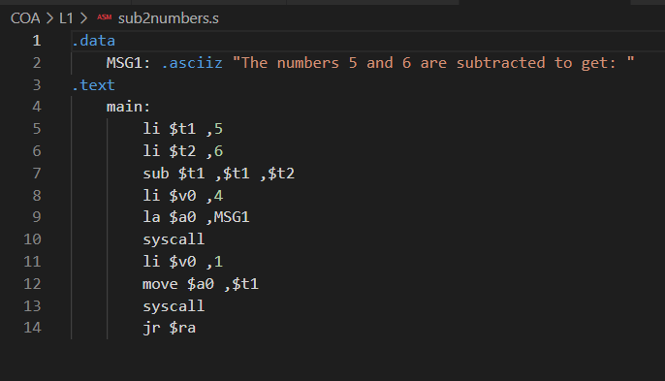

OUTPUT:

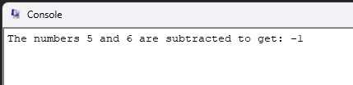

# Mul 2 Numbers

Code:

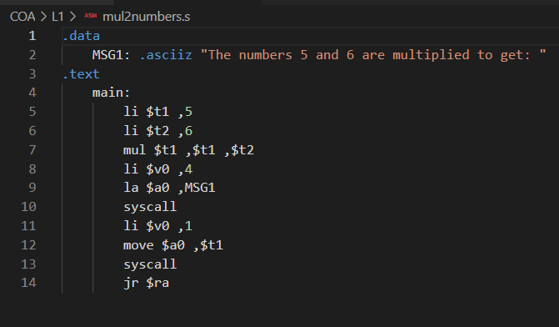

Output:

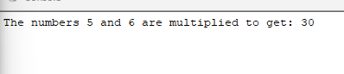

# Div 2 Numbers

Code:

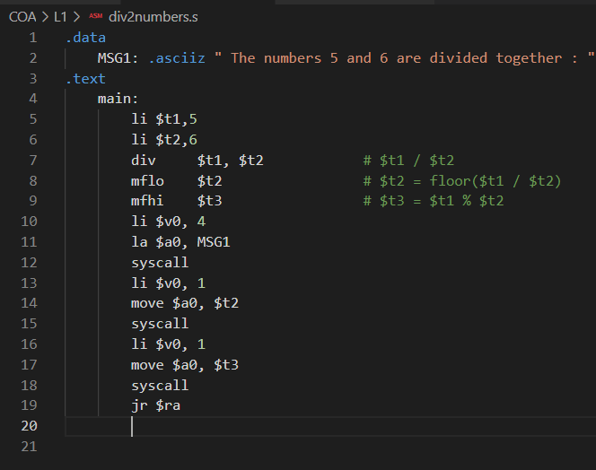

Output:

